This project is generously funded by an [NSF (EHR CORE Research Subcontract)](https://www.nsf.gov/awardsearch/showAward?AWD_ID=1348530). Practicing science is one of the most important goals of K-12 engineering education, which is now part of the Next Generation Science Standards. This project is delving into large quantities of process data to systematically identify bottlenecks in design processes that pose difficulties for students to apply science. Large learner datasets are being collected from over hundreds of students in Indiana and Massachusetts through automatic, unobtrusive logging of student design processes enabled by a unique CAD tool that supports the design of energy-efficient buildings using thermodynamics and heat transfer concepts. We have conducted a series of data mining studies in connecting with learning sciences theories to better understand students’ engineering design processes and its interaction with their science knowledge and performance.

CAD learning environment

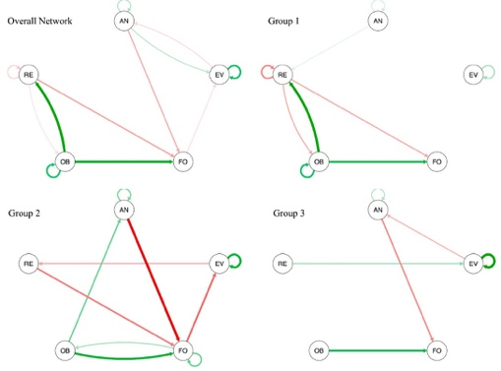

A network of SRL dynamics when students design energy houses in CAD learning environment

The reciprocal relationship between evaluation, reformulation, and design performance over time

Relevant Publications

Xing, W., Pei, B., Li, S., Chen, G., & Xie, C. (2019). Using learning analytics to support students’ engineering design: the angle of prediction. *Interactive Learning Environments*, 1-18.

Zheng, J., Xing, W., Zhu, G., Chen, G., Zhao, H., & Xie, C. (2020). Profiling self-regulation behaviors in STEM learning of engineering design. *Computers & Education*, *143*, 103669.

Li, S., Chen, G., Xing, W., Zheng, J., & Xie, C. (2020). Longitudinal clustering of students’ self-regulated learning behaviors in engineering design. *Computers & Education*, *153*, 103899.

Li, S., Du, H., Xing, W., Zheng, J., Chen, G., & Xie, C. (2020). Examining temporal dynamics of self-regulated learning behaviors in STEM learning: A network approach. *Computers & Education*, *158*, 103987.

Zheng, J., Xing, W., Huang, X., Li, S., Chen, G., & Xie, C. (2020). The role of self-regulated learning on science and design knowledge gains in engineering projects. *Interactive Learning Environments*, 1-13.

Huang, X., Xing, W., Zhao, H., Chao, J., Schimpf, C., Chen, G., & Xie, C. (2020). Understanding Science Learning Through Writings on Engineering Design.

Zhu, G., Zeng, Y., Xing, W., Du, H., & Xie, C. (2021). Reciprocal Relations Between Students’ Evaluation, Reformulation Behaviors, and Engineering Design Performance Over Time. *Journal of Science Education and Technology*, *30*(5), 595-607.